Group B

Prof. Stetler

BIOL-1015-03

04/05/23

1. Measure the abundance of Giberum in Lake Windfall during the summer months of each year from 1994 to 2006

| install.packages("adklakedata") install.packages("dplyr") install.packages("ggplot2") library(adklakedata) library(dplyr) library(ggplot2)  crustacean <- adk_data("crustacean")  lake_windfall <- filter(crustacean, lake.name == "Windfall") giberum <- filter(lake_windfall, Species == "giberum")  avg <- giberum %>% group_by(year) %>% summarise(mean_abundance = mean(mgWW.l))  ggplot(data=avg, aes(x=year, y=mean_abundance))+  ggtitle("Average Giberum Abundance in Lake Winfall During the Summer")+  geom_point(size=4)+  geom_smooth(method = "lm",se=FALSE,linetype="dashed")+  ylab("Average Animal Density (mg/L)")+  xlab("Year")+  scale_x_continuous(breaks = scales::pretty_breaks(n = 8))+  theme(plot.title = element_text(color="blue", size=12, face="bold"),  axis.title.x = element_text(color="darkblue", size=10, face="bold"),  axis.title.y = element_text(color="darkblue", size=10, face="bold"),  axis.text.x = element_text(color="lightblue", size=10),  axis.text.y = element_text(color="lightblue", size=10, angle=45),  panel.border = element_rect(colour = "black", fill=NA, size=2))  sum_lm <- lm(giberum$year ~ giberum$mgWW.l) summary(sum_lm) |
| --- |

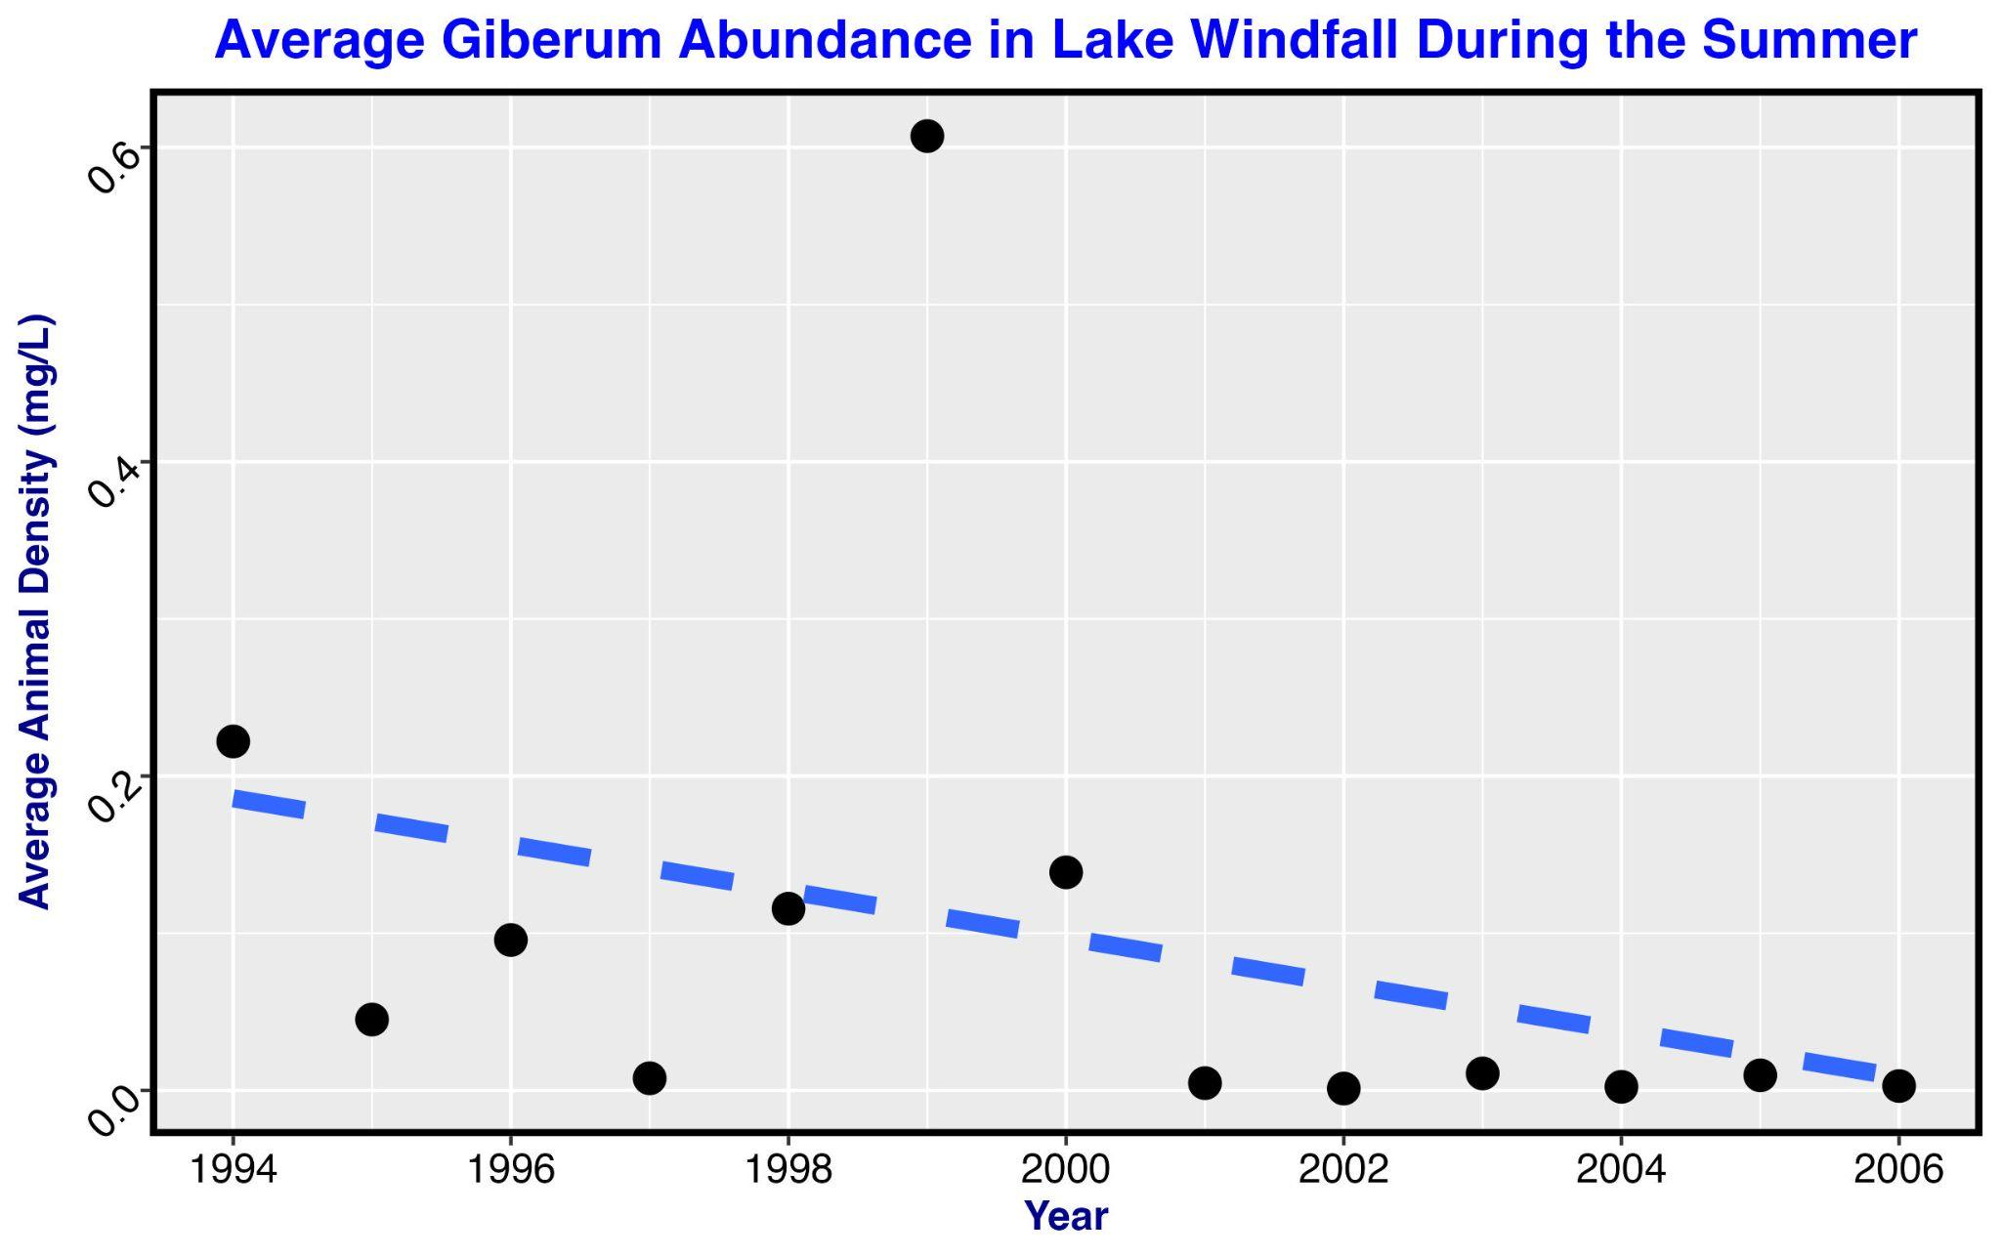

Figure 1. shows a plot and trendline of Giberum crustacean abundance in Lake Windfall during the summer months from 1994 to 2006.

* There seems to be a general decline in Giberum abundance .
* This may be due to the rise in pH.

Statistics shown below:

Residuals:

Min 1Q Median 3Q Max

-6.1960 -3.2787 0.8288 2.9296 5.8439

Coefficients:

Estimate Std. Error t value Pr(>|t|)

(Intercept) 2000.1960 0.8228 2430.925 <2e-16 ***

giberum$mgWW.l -7.1587 4.2223 -1.695 0.101

---

Signif. codes: 0 ‘***’ 0.001 ‘**’ 0.01 ‘*’ 0.05 ‘.’ 0.1 ‘ ’ 1

Residual standard error: 3.808 on 27 degrees of freedom

Multiple R-squared: 0.09622, Adjusted R-squared: 0.06275

F-statistic: 2.875 on 1 and 27 DF, p-value: 0.1015

1. Obtaining pH values

| windfall <- filter(chem, lake.name == "Windfall")  ann_avg <- windfall %>% group_by(ye  ar) %>% summarise(Average_Annual_pH = mean(pH))  sum_lm <- lm(ann_avg$year ~ ann_avg$Average_Annual_pH) summary(sum_lm)  ggplot(data=ann_avg, aes(x=year, y=Average_Annual_pH)) +  geom_point(size = 3) +  scale_x_continuous(breaks = scales::pretty_breaks(n = 8)) +  geom_smooth(method="lm",se=FALSE,color="darkblue",linetype="dashed",size = 2.5) +  ggtitle("Windfall Average pH Per Year") + ylab("pH") + xlab("Year") +  theme(plot.title = element_text(color="blue", size=22, face="bold"),  axis.title.x = element_text(color="darkblue", size=18, face="bold"),  axis.title.y = element_text(color="darkblue", size=18, face="bold"),  axis.text.x = element_text(color="black", size=16),  axis.text.y = element_text(color="black", size=16, angle=45),  panel.border = element_rect(colour = "black", fill=NA, size=2)) |
| --- |

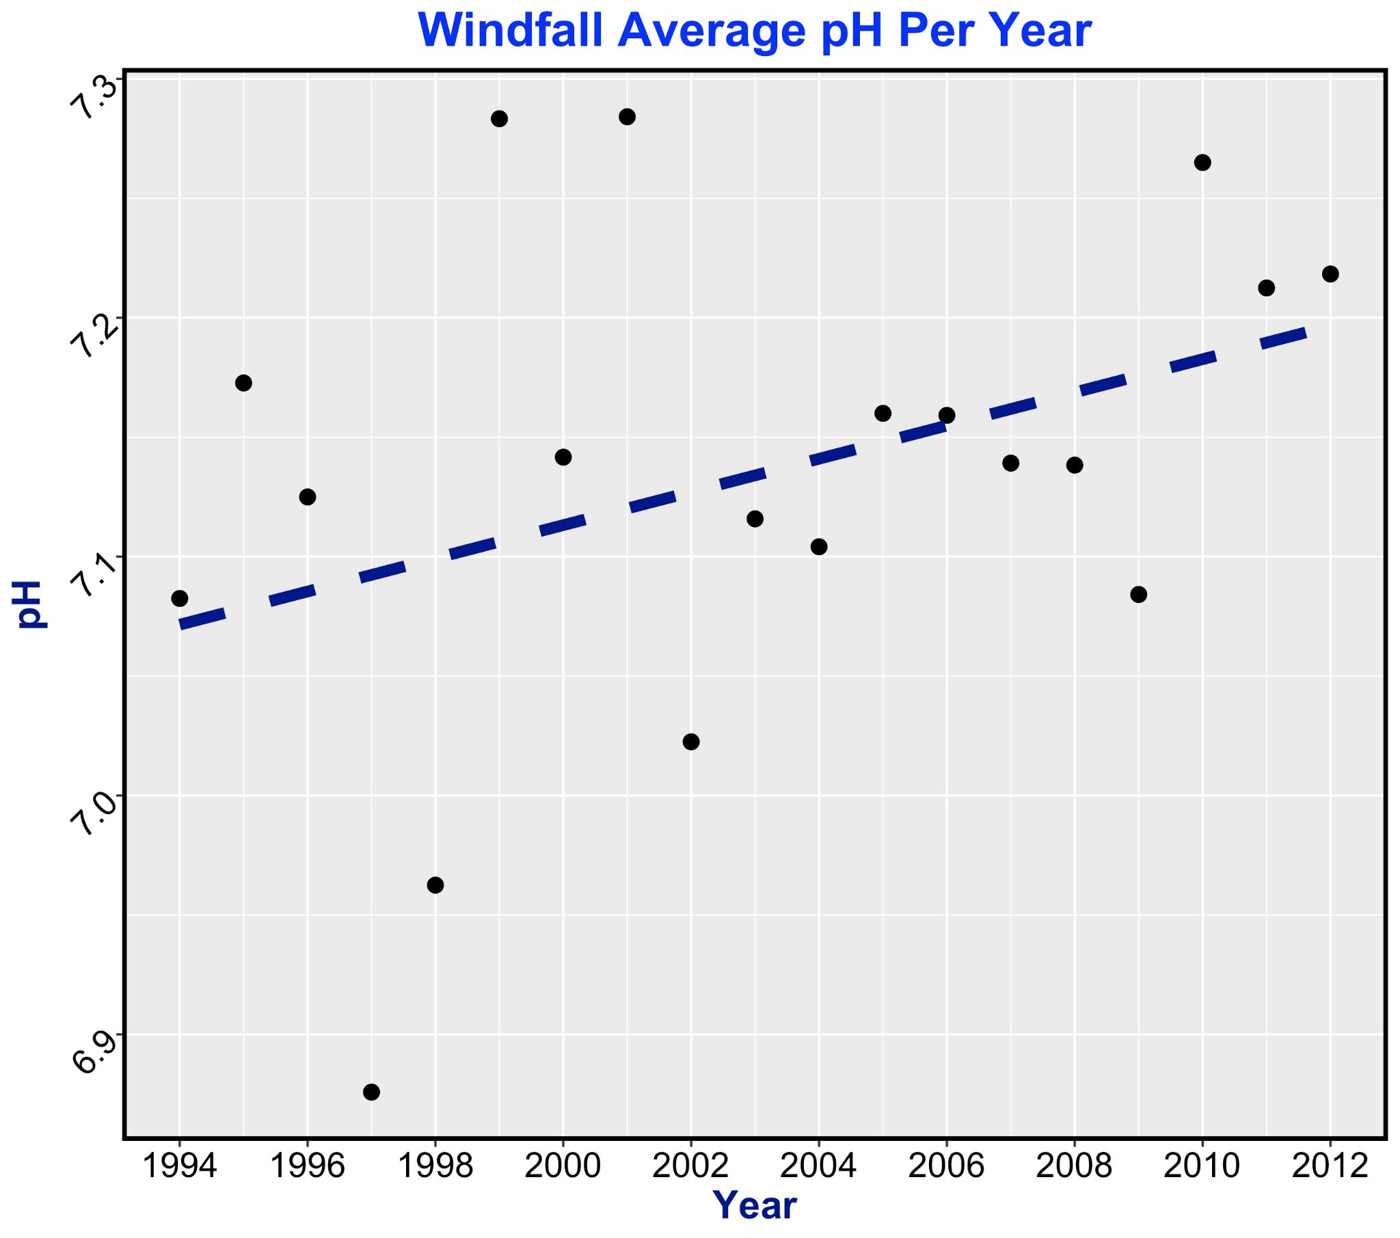

Figure 2. shows a plot with a trendline of the average Ph per year in Lake Windfall from 1994 to 2012

* The average pH per year is increasing over time
* The increase in pH may be the cause of the decreasing Giberum population

Residuals:

Min 1Q Median 3Q Max

-8.793 -4.117 1.287 4.105 7.272

Coefficients:

Estimate Std. Error t value Pr(>|t|)

(Intercept) 1856.76 87.06 21.33 1.04e-13 ***

ann_avg$Average_Annual_pH 20.50 12.20 1.68 0.111

---

Signif. codes: 0 ‘***’ 0.001 ‘**’ 0.01 ‘*’ 0.05 ‘.’ 0.1 ‘ ’ 1

Residual standard error: 5.362 on 17 degrees of freedom

Multiple R-squared: 0.1424, Adjusted R-squared: 0.09193

F-statistic: 2.822 on 1 and 17 DF, p-value: 0.1112

1. Analyzing Phosphorus

| nutrients <- adk_data("nutrient") nutrients_windfall <- filter(nutrients, lake.name == "Windfall") phosphorus_by_year <- nutrients_windfall %>% group_by(year) %>% summarise(mean_TotalP = mean(TotalP.ug.L)) ggplot(data=phosphorus_by_year, aes(x=year, y=mean_TotalP))+   ggtitle("Average Total Phosphorus in Lake Windfall During the Summer by Microgram")+  theme(plot.title = element_text(hjust = 0.5))+  geom_point(size = 4)+   geom_smooth(method = "lm",se=FALSE,linetype="dashed",size=2.5)+  ylab("Phophorus (ug)")+   xlab("Year")+  scale_x_continuous(breaks = scales::pretty_breaks(n = 8))+  scale_y_continuous(breaks = scales::pretty_breaks(n = 6))+  theme(plot.title = element_text(color="blue", size=16, face="bold"),  axis.title.x = element_text(color="darkblue", size=12, face="bold"),  axis.title.y = element_text(color="darkblue", size=12, face="bold"),  axis.text.x = element_text(color="black", size=12),  axis.text.y = element_text(color="black", size=12, angle=45),  panel.border = element_rect(colour = "black", fill=NA, size=2)) |
| --- |

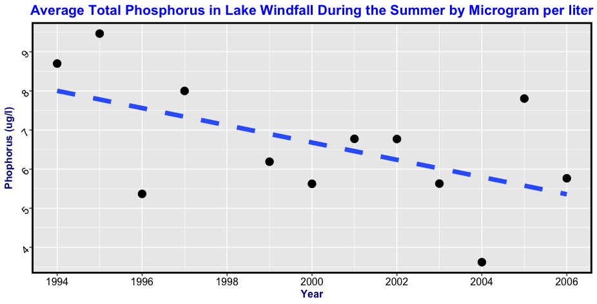

Figure 3. shows a plot and trendline of total Phosphorus in micrograms per liter in Lake Windfall during the summer months from 1994 to 2006.

* There seems to be a general decline in total Phosphorus.
* This may be due to the rise in pH.
* The decrease is good because too much Phosphorus in water can lead to decreased levels of dissolved oxygen, however too little Phosphorus is bad because phosphorus is needed by vegetation and soil microbes for normal growth.

Residuals:

Min 1Q Median 3Q Max

-2.1949 -0.7962 0.3622 0.6686 2.2280

Coefficients:

Estimate Std. Error t value Pr(>|t|)

(Intercept) 447.6802 215.3631 2.079 0.0643 .

phosphorus_by_year$year -0.2205 0.1077 -2.048 0.0677 .

---

Signif. codes: 0 ‘***’ 0.001 ‘**’ 0.01 ‘*’ 0.05 ‘.’ 0.1 ‘ ’ 1

Residual standard error: 1.435 on 10 degrees of freedom

Multiple R-squared: 0.2955, Adjusted R-squared: 0.225

F-statistic: 4.194 on 1 and 10 DF, p-value: 0.06775

5. Bar graphs

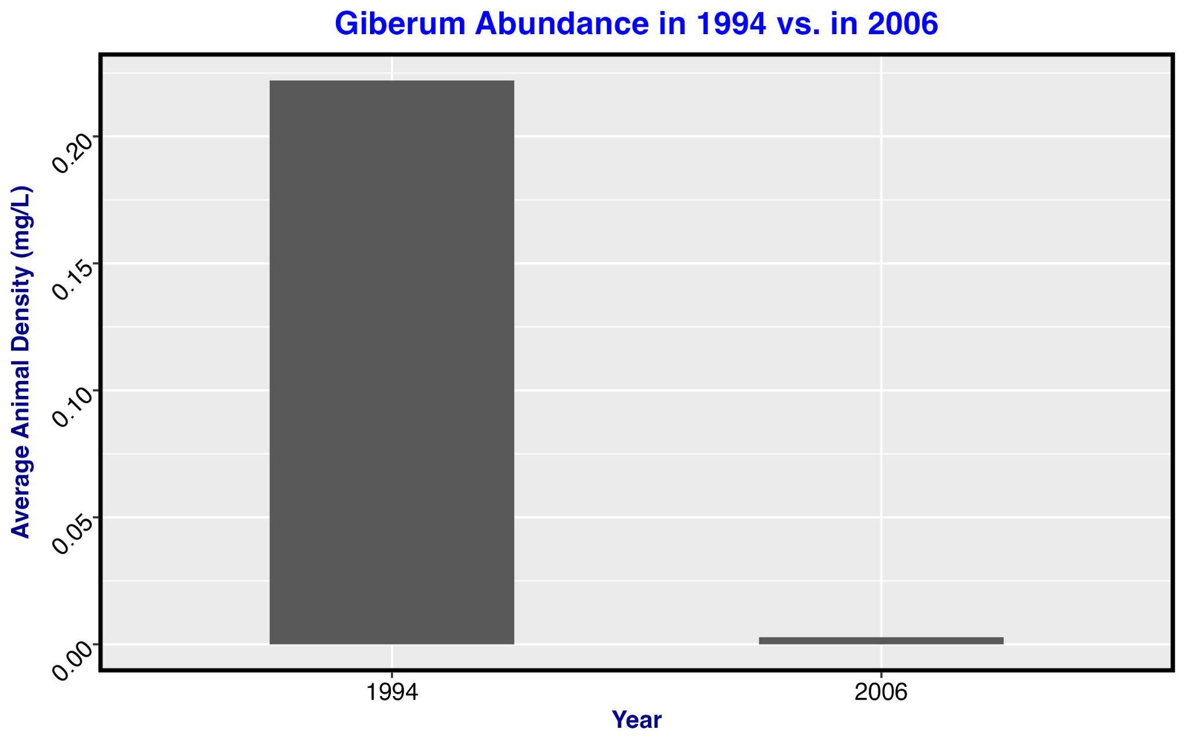

Figure 4. shows a bar graph of the difference between the first year of Giberum measured and the latest year of Giberum measured

* There is a noticeable decline in Giberum.
* This could be a result of the increase of pH.

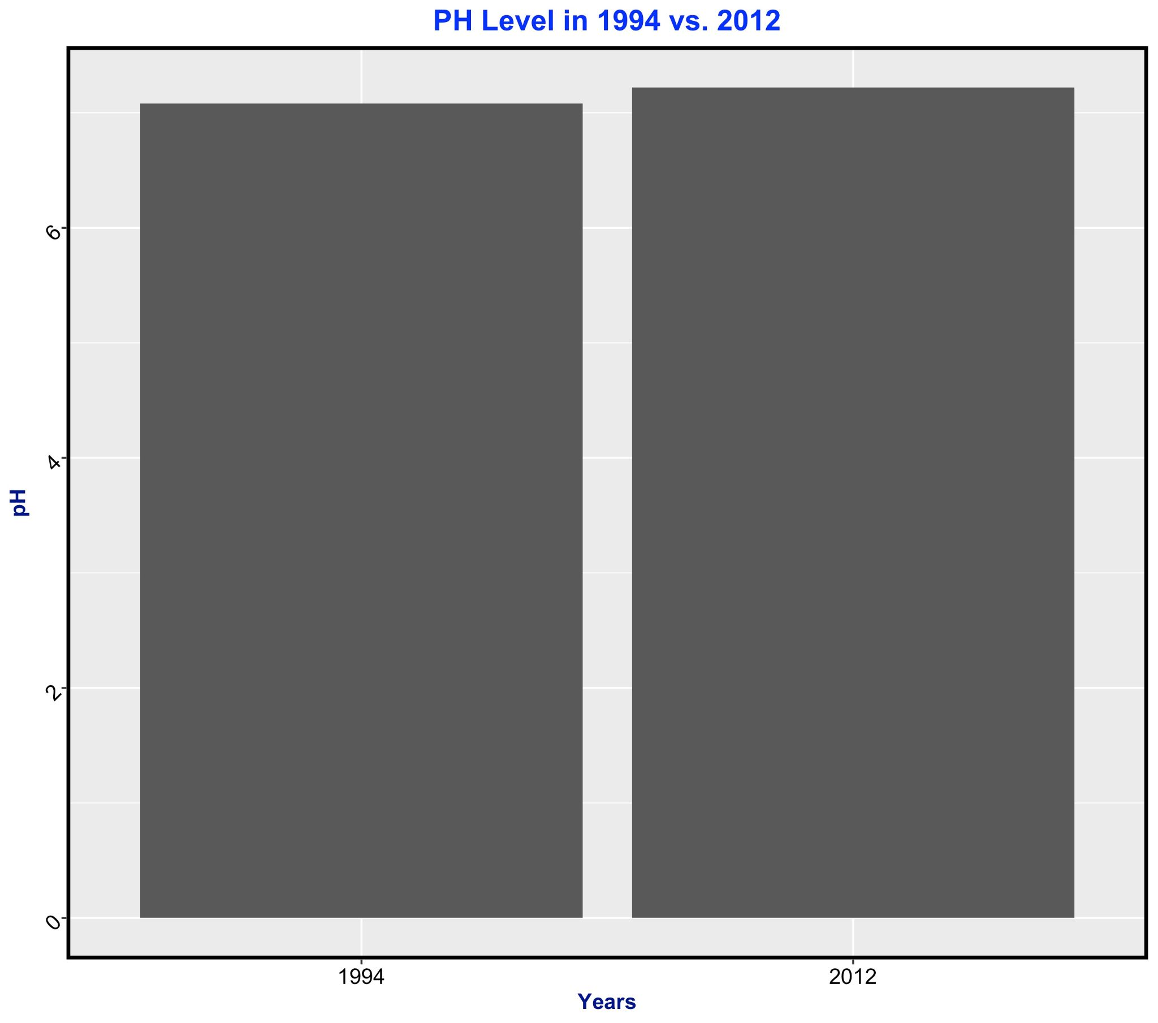

Figure 5. shows a bar graph of the difference in pH levels of Lake Windfall in 1994 as opposed to 2012.

* There was an increase in pH levels in Lake Windfall.
* This most likely influenced the other variables measured such as the abundance of Giberum and the amount of phosphorus.

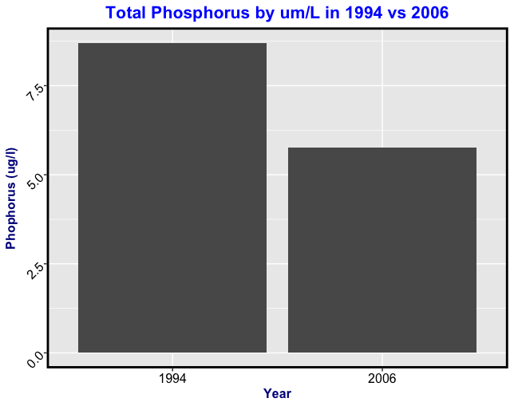

Figure 6. shows a bar graph of the difference between the first year of total phosphorus measured and the latest year total phosphorus was measured

* There is a decline in Phosphorus.
* This could be a result of the increase of pH.